Spring Boot

ST01: Getting started with Spring Boot
- We will learn Spring Boot Framework by Building a Hello World Application using Modern Spring Boot Approach

- Hands on with Spring Boot & learn important concepts of it.

- Also we will see why Spring Boot is needed & how it makes it easy to develop applications or microservices.

- Terminologies associated with the Spring Boot:
  - Spring Initializr
  - Auto Configuration
  - Starter Project
  - Actuator
  - Developer Tools

ST02: Setting up a new Spring Boot project using Spring Initializr

Spring Boot Project using Spring Initializr will be created the same as we did for Spring Framework.

Additionally, we need to add Spring Web dependency by clicking the ‘Add Dependencies’ button. Search for ‘Spring Web’ dependency & click to add in the project.
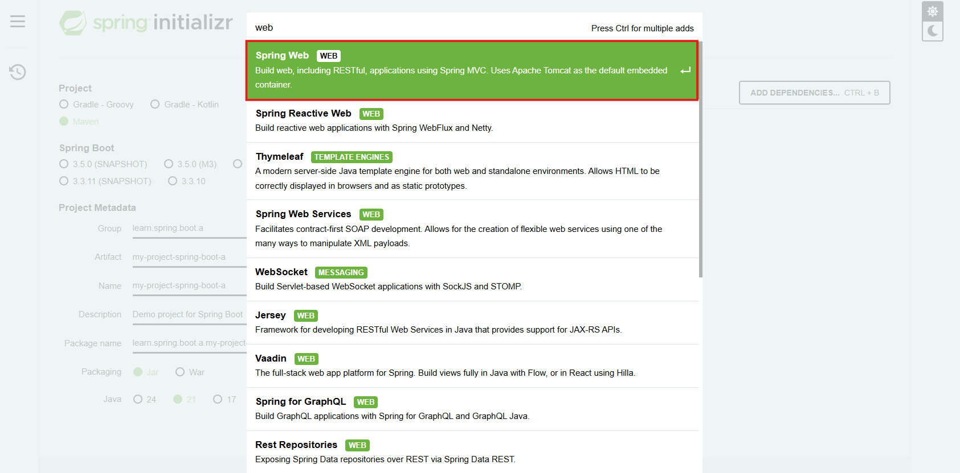

Spring Web
As we want to build a simple REST API & in Spring Boot we can build it by using Spring Web. That’s why we need to add this dependency. This allows us to build Rest APIs using Spring MVC & run them on TOMCAT as the embedded Server.
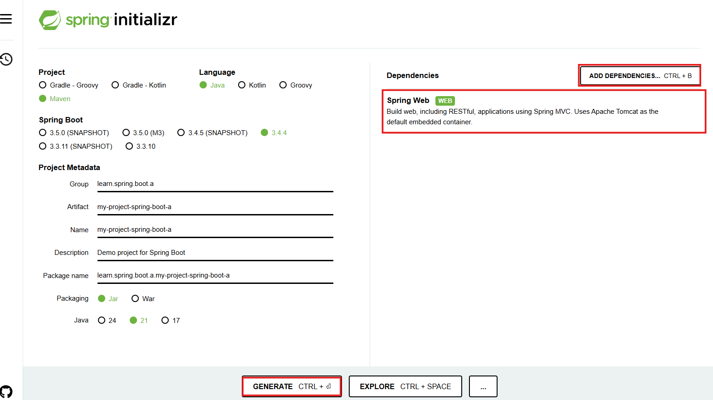

Now, generate the project & import to the Workspace as an existing MAVEN project.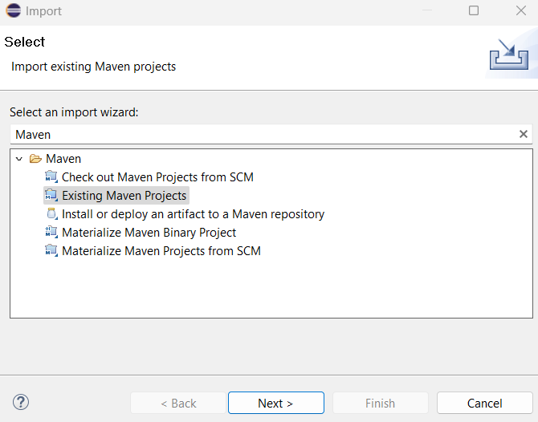
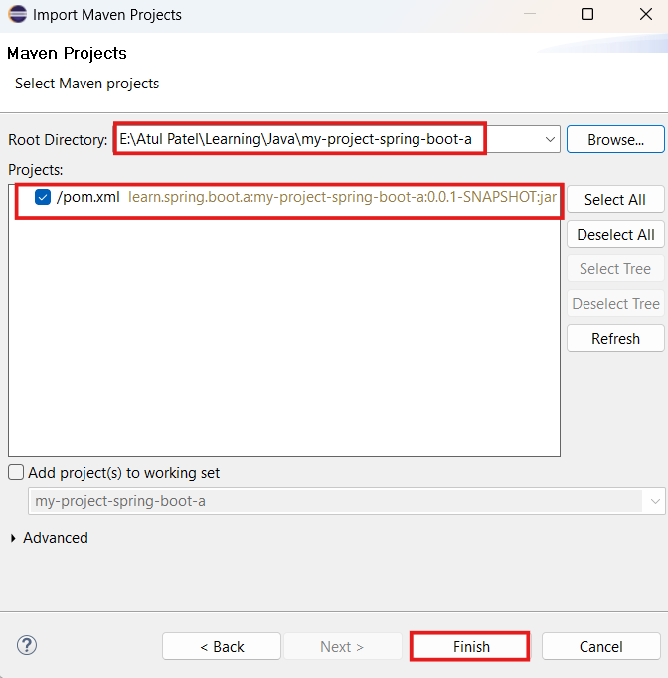

Once imported we will see that a lot of Spring Boot Maven dependencies are added.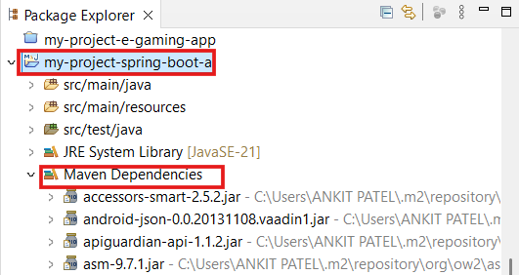
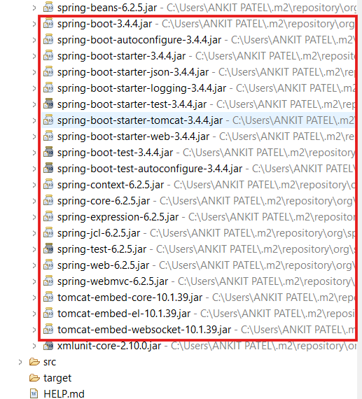

This is because the dependencies for the Spring Boot started has been added in the pom.xml file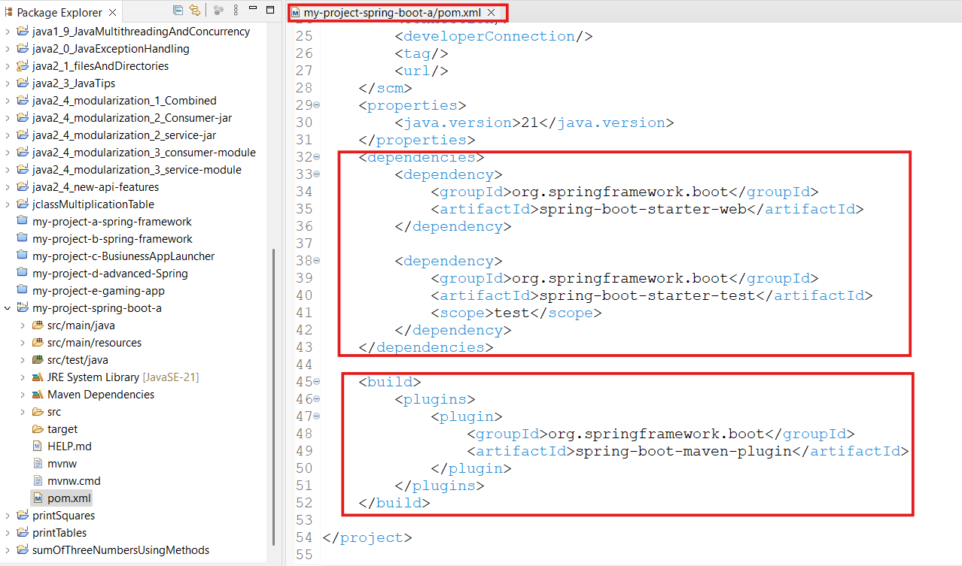

src/main.java - In this file, we will be writing our logic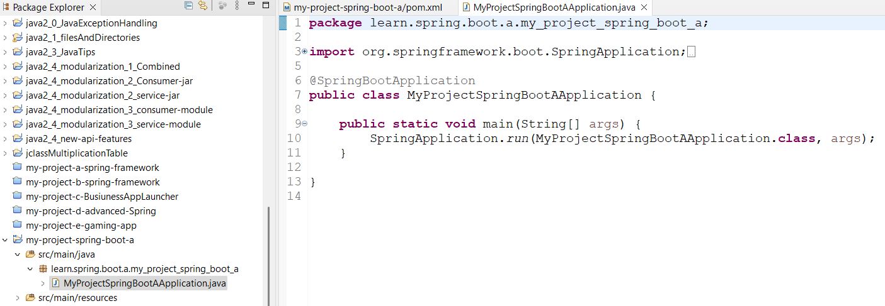

Let’s launch the application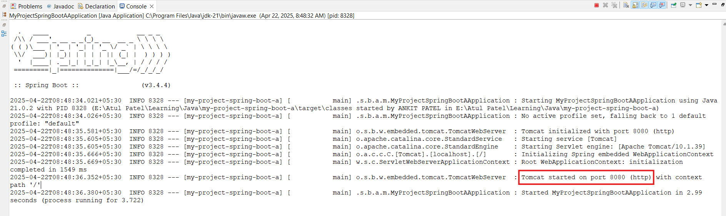
We can see that a new Spring Boot application is launched successfully.

ST03: Build a HelloWorld API with Spring Boot

Let’s create an application to
- Expose URL - http://localhost:8080/courses
- Return the list of courses as follows:
[
{
"id": 1,
"name": "Learn Microservices",
"author": "APatel"
},
{
"id": 2,
"name": "Learn Spring Boot",
"author": "AtulP"
}
]

So if the above URL is requested, we need to respond back with the above response.
Now, starting with the development:
- Create a CourseController class in the package:
Learn.spring.boot.a.my_project_spring_boot_b.courses.controller

Now using an Annotation → ‘@RestController’, we can expose the URL

In the body of the class, we need to write a logic to respond back with the list of courses. This is done using Annotation - ‘@GetMapping(“uri”)’.
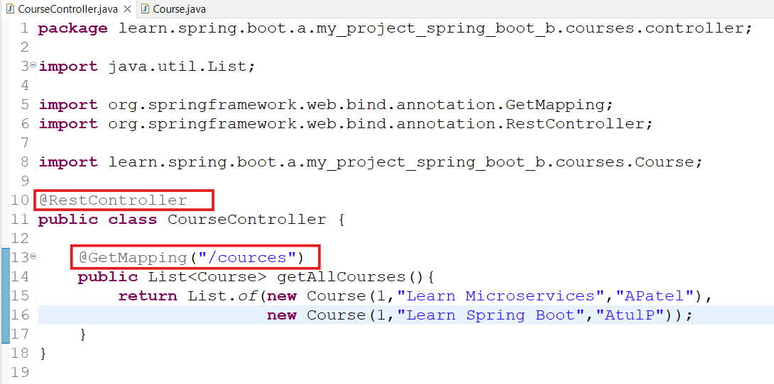
This method will return the list of courses.

- Create the Course class:
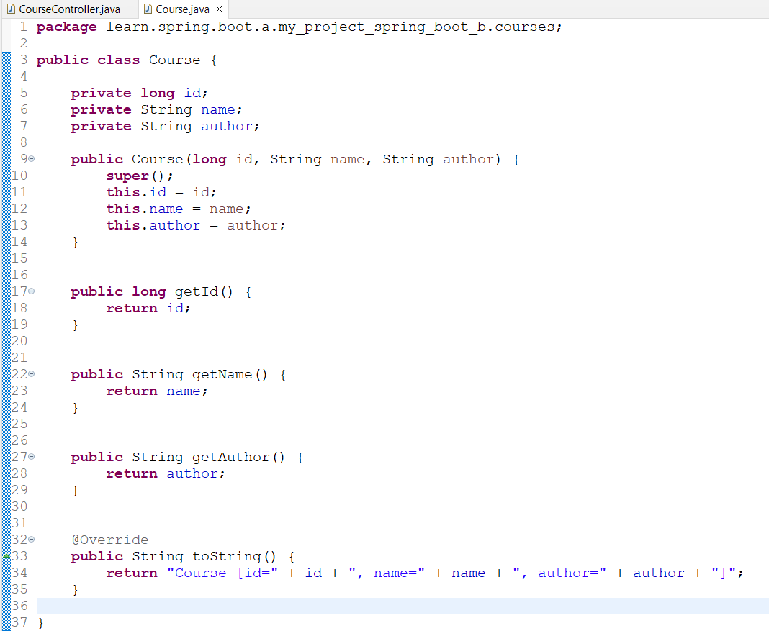
- Now Launch the Application

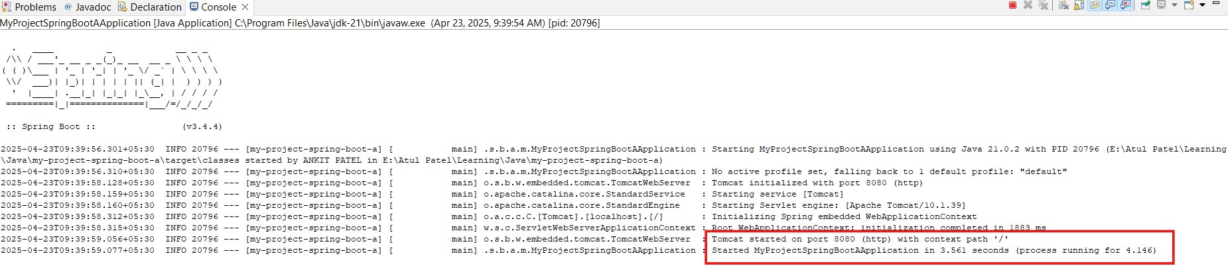
Application has been launched successfully

- Now trigger the URL: http://localhost:8080/courses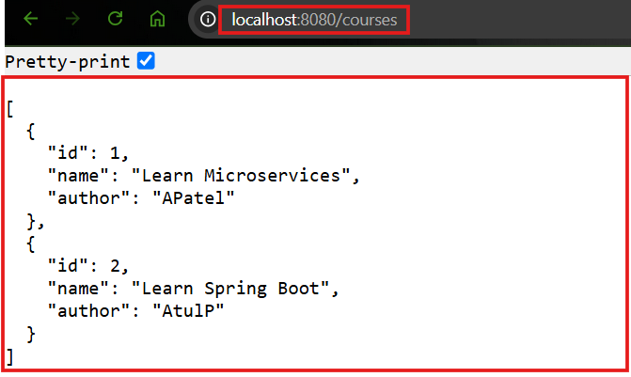
The expected response has been returned.

ST04: World before Spring Boot

Before the evolution of Spring Boot, if we needed to build a simple application using Spring Framework, Spring MVC & needed to run on TOMCAT.

There are a lot of things that are needed to be defined in the pom.xml file

Setting up Spring Web Projects was not easy.
- There were a lot of MAVEN dependencies that needed to be defined & managed versions for the framework. So if we need to change the version, we need to update the versions manually in the maven dependencies.
Example - spring-webmvc, jackson-databing, log4j etc.
- We also needed to define a web.xml file for our web application where we need to configure servlets.
Define Front Controller for Spring Framework(DispatcherServerlet)
- After that we needed to define a Spring context xml file where we needed to define all the required beans.
- Also we needed to install Tomcat or use tomcat7-maven-plugin (or any other web server).
- Finally we needed to build & run our application

But with Spring Boot,
- we just need to create the project using Spring Initializr. This contains all the required resources & dependencies not all the complex stuff discussed above.
- When we ran the application , we saw that it is making use of Tomcat as well.

This is because a lot of things happened behind it, which provides an ease in building any web application or REST APIs or any other Microservices using Spring Boot.

Now we will see how this is all happening by understanding:
- Spring Boot Started Project
- Spring Boot Auto Configuration

ST05: Spring Boot Magic - Spring Boot Starter Project

These are the one of the fundamental blocks of Spring Boot which helps us in getting a project up & running very quickly.

- To develop a Web Application or Rest API - ‘Spring Boot Starter Web’ will be used.
For example - while building a Hello World Application, we chose a dependency - Spring Web which is a Spring Boot Starter web.

Also a dependency was added for the starter in the pom.xml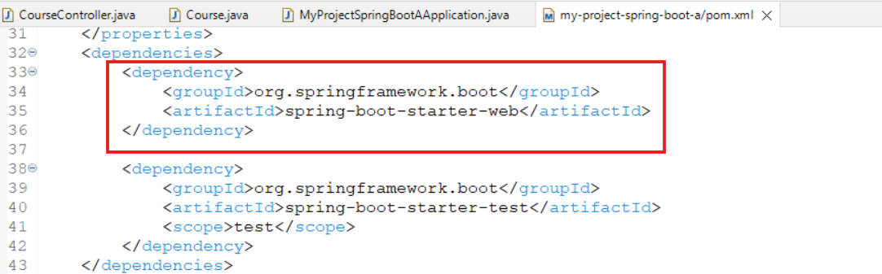

Further if we expand “spring-boot-starter-web”, we will see another pom.xml is getting expanded where a number of dependencies are defined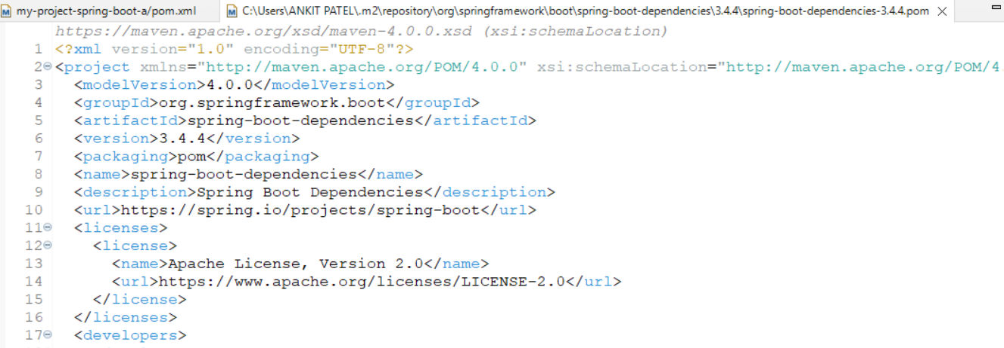

We can see the starter-json dependency which is responsible for converting the response into json format. That is the reason on the web response we get responses in json format.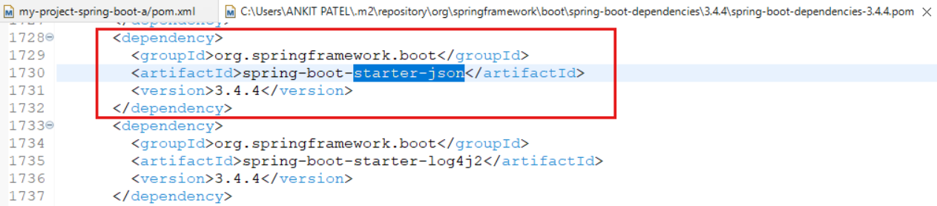

We want to run our application in tomcat that is also added as dependency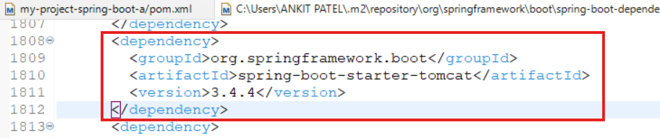

- Similarly, to create a Rest API or web application using spring webmvc, the below dependency enables us to do it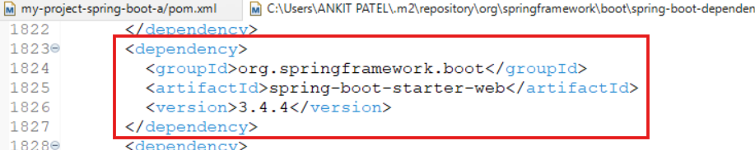
- Communication to the Database using JPA or hibernate - “spring-boot-starter-data-jpa” starter is used 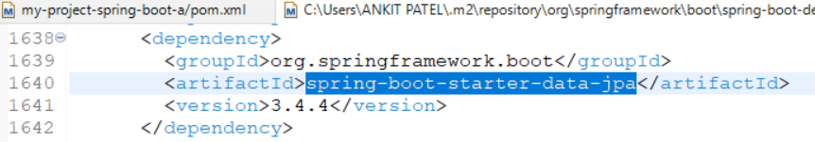
- Communication to the Database using JDBC - “spring-boot-starter-jdbc” starter is used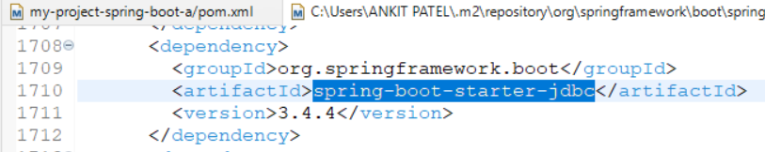
- Secure Web Application or Rest API - “spring-boot-starter-security” starter is used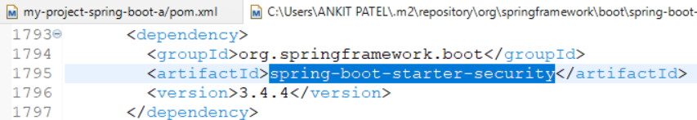

There are a lot of starters available, we can go & add dependency required while creating a project using Spring Initializr.

Each starter manages a list of MAVEN dependencies & versions for different kinds of applications.for example we have seen the above dependencies managed by the Spring Boot Starter Web

Spring Boot Starter Web: It contains the framework needed by our framework.

But all of the dependencies we do not need to manually manage. But just the starter we need to configure in the pom.xml file & all the dependencies will be auto downloaded.

ST06: Spring Boot Magic - Spring Boot Auto Configuration

Spring Boot starter project defines a set of dependencies & once these are added, we will be having a number of frameworks or classes added in the classpath 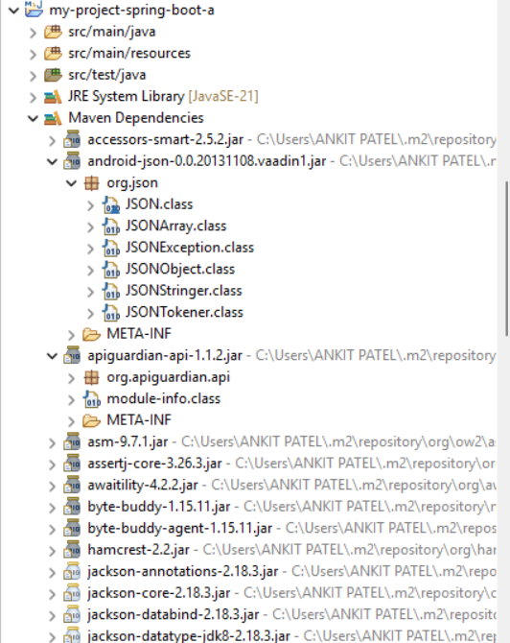
We can see the above jars, which have several classes.

So based on the classes available in the classpath, Java provides Auto-Configuration.

- Spring Boot provides auto configuration to run our application using the frameworks defined in our maven dependencies.
- Auto Configuration is decided based on-
  - Which frameworks are in the class Path?
  - What is the existing configuration(Annotations etc)?
- All the Auto configuration info is defined in a jar called - springframework.boot.autoconfigure

- An Example: (Enable debug logging for more details):
If you use Spring Boot Starter Web, following are auto configured:
- Dispatcher Servlet (DispatcherServletAutoConfiguration)

- Embedded Servlet Container - Tomcat is the default (EmbeddedWebServerFactoryCustomizerAutoConfiguration)

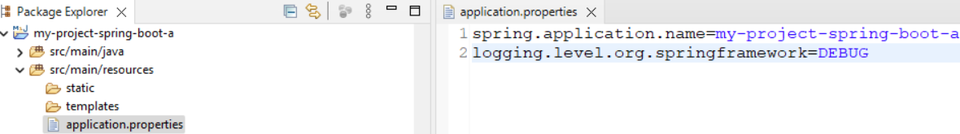
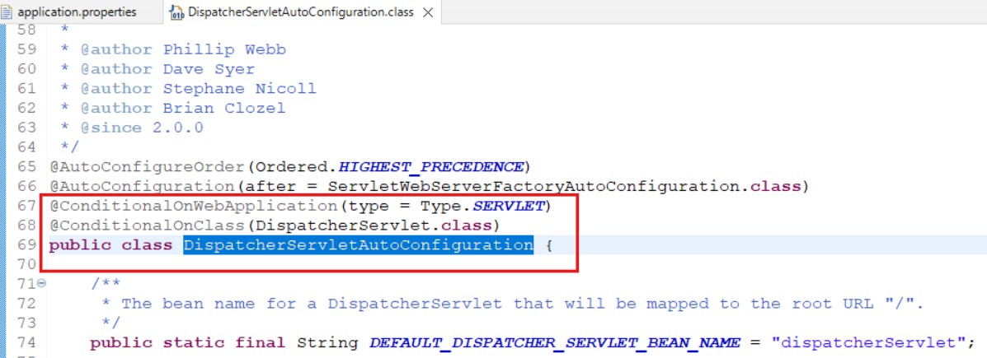

So here few conditions are mentioned & if the conditions match only then the call is auto configured else ignored.

- Default Error Pages (ErrorMvcAutoConfiguration) - This is autoconfiguration so that in case any error is not handled by the developer , Spring will respond with a proper Error response:
Eg: for our Application , we did not configure any error scenario, so Spring by default handles it & responds as follows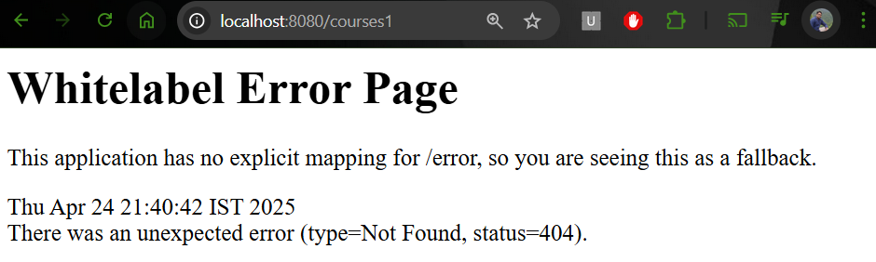

- Bean to/from JSON Conversion - is done by JacksonHttpMessageConvertersConfiguration framework.

Therefore, we can say that these auto configurations enable us to take care of only business logic without bothering about the rest of the configurations.

ST07: Spring Boot - Embedded Server - TOMCAT

In the Old days, there were a lot of complexity in building & launching the application:
- Install Java
- Install & Configure Web/Application Server - servers like - Tomcat, WebSphere or WebLogic
- Deploy the Application WAR(Web Archive)

But with the Modern Approach- JAR Approach(Embedded Server) it becomes very easy, we just need to -
- Install Java
- Run JAR file.
Example: Let’s create JAR file for our application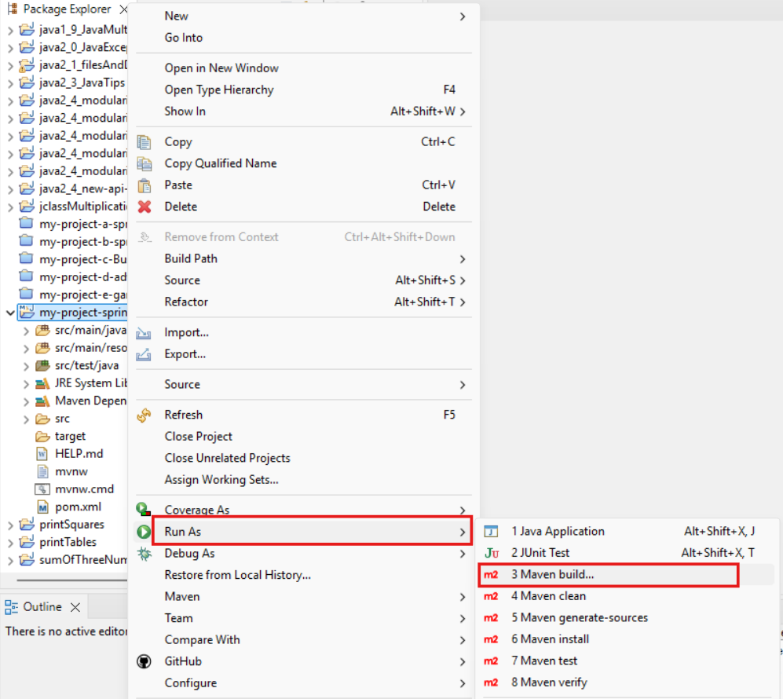
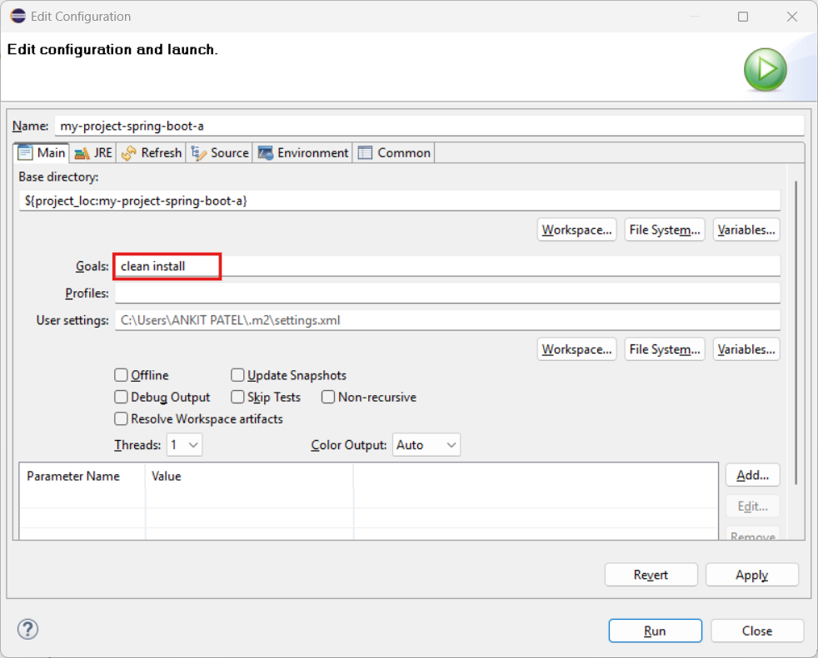
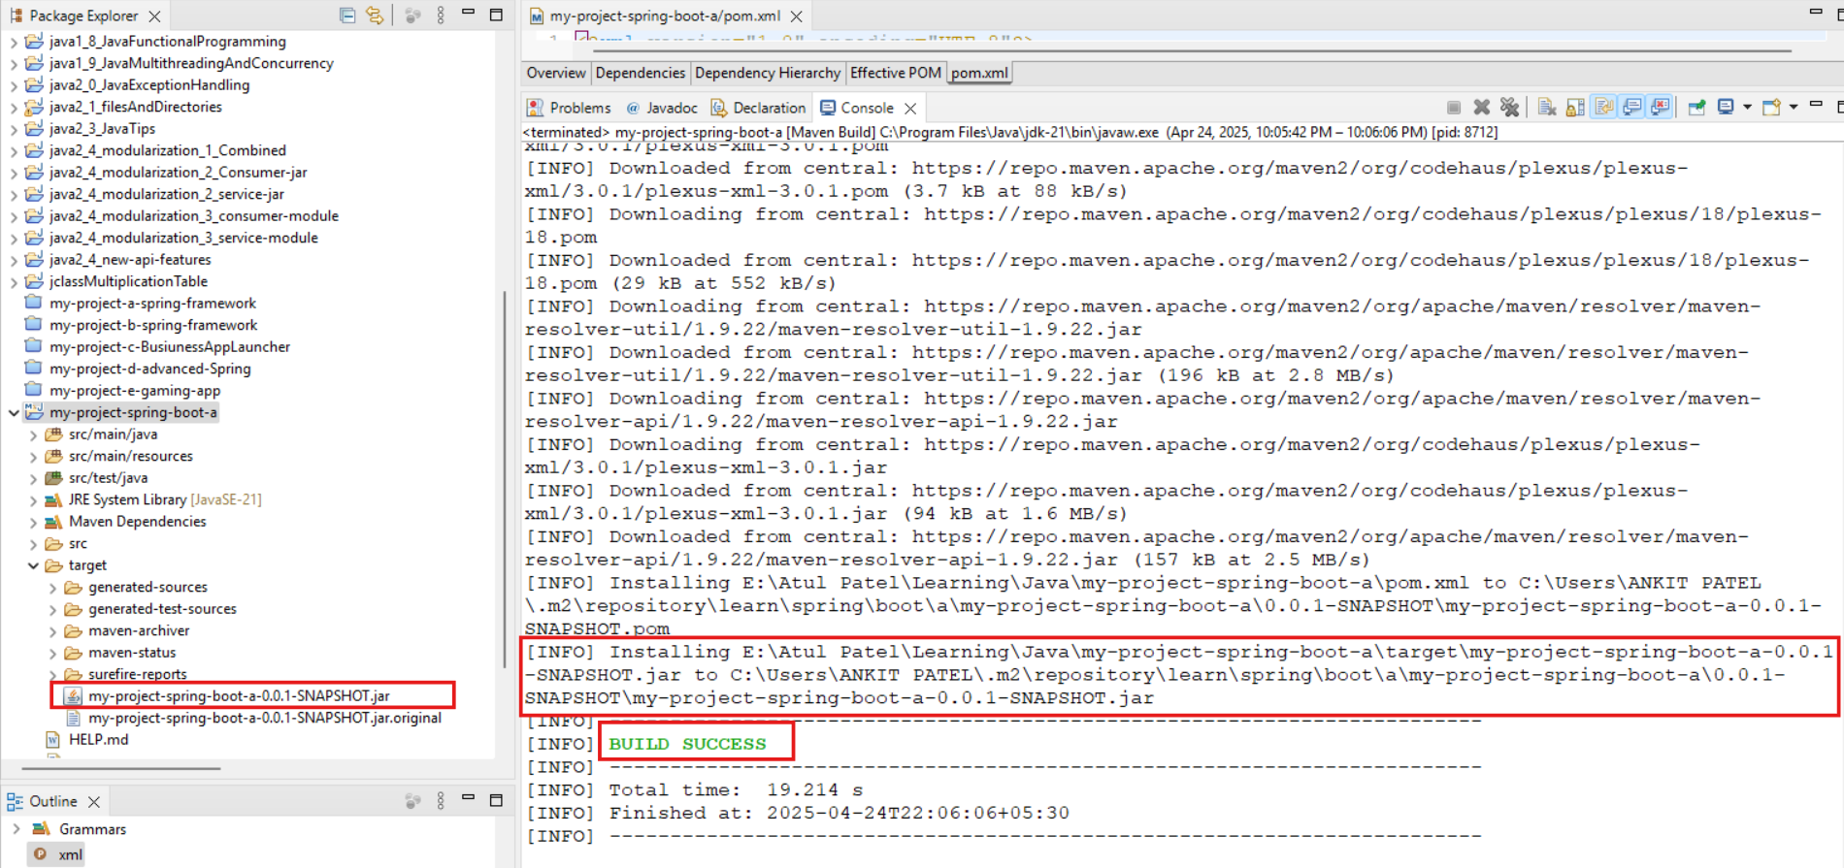
Build is successful & JAR is created in below file:
E:\Atul Patel\Learning\Java\my-project-spring-boot-a\target\my-project-spring-boot-a-0.0.1-SNAPSHOT.jar
to
C:\Users\ANKIT PATEL\.m2\repository\learn\spring\boot\a\my-project-spring-boot-a\0.0.1-SNAPSHOT\my-project-spring-boot-a-0.0.1-SNAPSHOT.jar
Now pickup the target folder & launch the application in cmd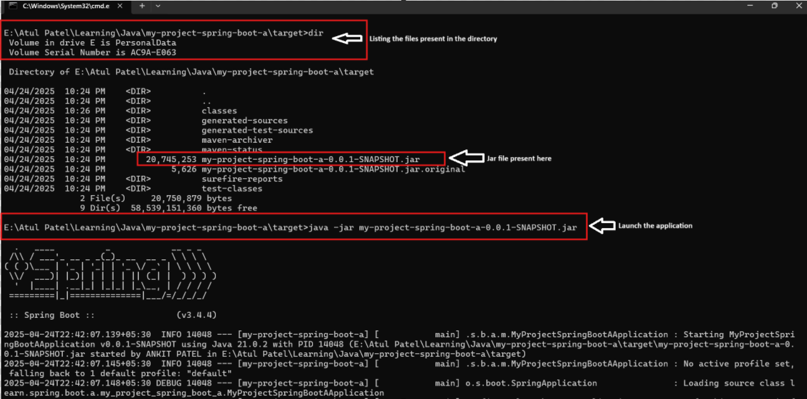

Successfully Launched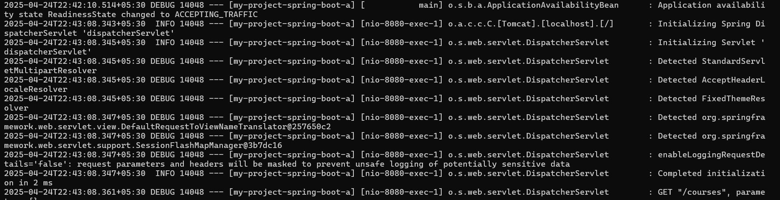

Run Application:
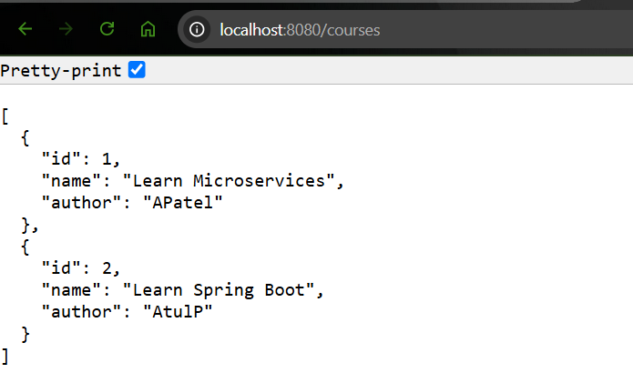

This is all happening because of the embedded - TOMCAT server.

ST08: Exploring Spring Boot Actuator

- One of the important goals of the Spring Boot is to provide us with a Production-Ready application very easily.

- Also one of the Typical needs in the production is to Monitor application.

- Therefore Spring Boot provides a feature called Spring Boot Actuator which helps us in Monitoring & Managing Applications in Production.

- Spring Boot Actuators provide a number of endpoints. We can look into the -
  - Beans: Complete list of Beans in our application
  - Health: Application health information
  - Metrics: Different metrics behind the applications
  - Mappings: Details around the Request Mappings

Let’s get started with Spring Boot Actuators:
- Add a Maven Dependency in the pom.xml file - Similar to ‘spring-boot-starter-web’ we have ‘spring-boot-starter-actuator’ that we need to add.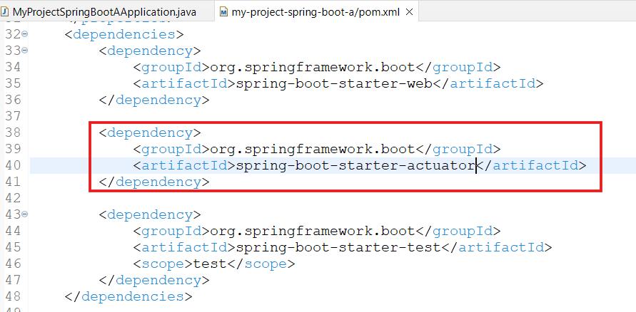
- Launch the application
- The URL for the Actuator is - ‘http://localhost:8080/actuator’. Trigger the URL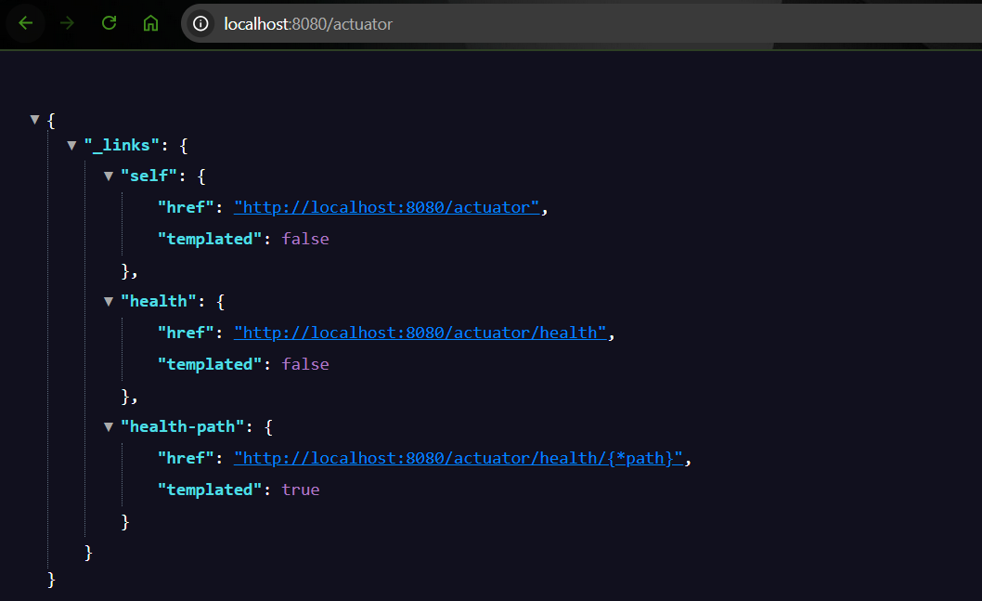
We can see it returns 3 URLs by default. We can click on it & see the further details.

  - Health API
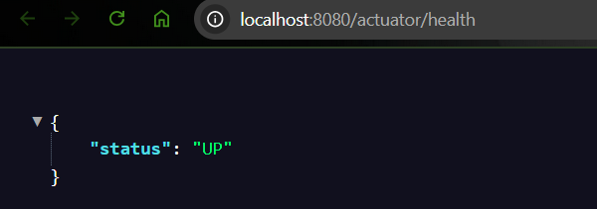
- By default, the above APIs are enabled, but we can enable a lot more. For that we can go to the application.properties file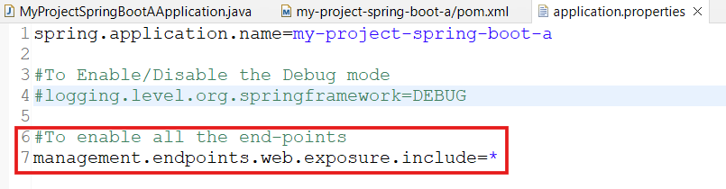
- Now Restart the server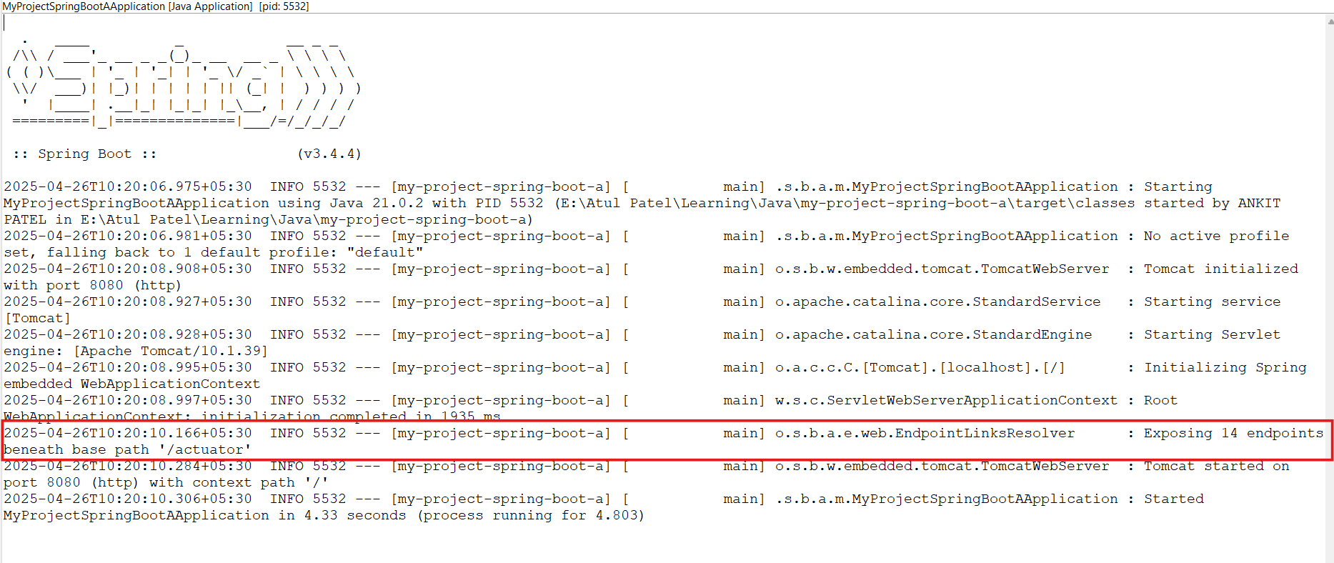
- Rerun the actuator api
{
"_links": {
"self": {
"href": "http://localhost:8080/actuator",
"templated": false
},
"beans": {
"href": "http://localhost:8080/actuator/beans",
"templated": false
},
"caches-cache": {
"href": "http://localhost:8080/actuator/caches/{cache}",
"templated": true
},
"caches": {
"href": "http://localhost:8080/actuator/caches",
"templated": false
},
"health": {
"href": "http://localhost:8080/actuator/health",
"templated": false
},
"health-path": {
"href": "http://localhost:8080/actuator/health/{*path}",
"templated": true
},
"info": {
"href": "http://localhost:8080/actuator/info",
"templated": false
},
"conditions": {
"href": "http://localhost:8080/actuator/conditions",
"templated": false
},
"configprops": {
"href": "http://localhost:8080/actuator/configprops",
"templated": false
},
"configprops-prefix": {
"href": "http://localhost:8080/actuator/configprops/{prefix}",
"templated": true
},
"env": {
"href": "http://localhost:8080/actuator/env",
"templated": false
},
"env-toMatch": {
"href": "http://localhost:8080/actuator/env/{toMatch}",
"templated": true
},
"loggers": {
"href": "http://localhost:8080/actuator/loggers",
"templated": false
},
"loggers-name": {
"href": "http://localhost:8080/actuator/loggers/{name}",
"templated": true
},
"heapdump": {
"href": "http://localhost:8080/actuator/heapdump",
"templated": false
},
"threaddump": {
"href": "http://localhost:8080/actuator/threaddump",
"templated": false
},
"metrics-requiredMetricName": {
"href": "http://localhost:8080/actuator/metrics/{requiredMetricName}",
"templated": true
},
"metrics": {
"href": "http://localhost:8080/actuator/metrics",
"templated": false
},
"sbom-id": {
"href": "http://localhost:8080/actuator/sbom/{id}",
"templated": true
},
"sbom": {
"href": "http://localhost:8080/actuator/sbom",
"templated": false
},
"scheduledtasks": {
"href": "http://localhost:8080/actuator/scheduledtasks",
"templated": false
},
"mappings": {
"href": "http://localhost:8080/actuator/mappings",
"templated": false
}
}
}

- There are a lots of Informations that can be investigated using above URLs

API name | API Function
actuator/health | Health of the API
actuator/beans | Returns all the Beans created in the project
actuator/env | Provides info about the environment in which API Server is running
actuator/metrics | Provides info about the metrics like: API start time, http server requests(counts) etc

- Metrics API
{
"names": [
"application.ready.time",
"application.started.time",
"disk.free",
"disk.total",
"executor.active",
"executor.completed",
"executor.pool.core",
"executor.pool.max",
"executor.pool.size",
"executor.queue.remaining",
"executor.queued",
"http.server.requests",
"http.server.requests.active",
"jvm.buffer.count",
"jvm.buffer.memory.used",
"jvm.buffer.total.capacity",
"jvm.classes.loaded",
"jvm.classes.unloaded",
"jvm.compilation.time",
"jvm.gc.concurrent.phase.time",
"jvm.gc.live.data.size",
"jvm.gc.max.data.size",
"jvm.gc.memory.allocated",
"jvm.gc.memory.promoted",
"jvm.gc.overhead",
"jvm.gc.pause",
"jvm.info",
"jvm.memory.committed",
"jvm.memory.max",
"jvm.memory.usage.after.gc",
"jvm.memory.used",
"jvm.threads.daemon",
"jvm.threads.live",
"jvm.threads.peak",
"jvm.threads.started",
"jvm.threads.states",
"logback.events",
"process.cpu.time",
"process.cpu.usage",
"process.start.time",
"process.uptime",
"system.cpu.count",
"system.cpu.usage",
"tomcat.sessions.active.current",
"tomcat.sessions.active.max",
"tomcat.sessions.alive.max",
"tomcat.sessions.created",
"tomcat.sessions.expired",
"tomcat.sessions.rejected"
]
}

  - Further lets see the ‘http://localhost:8080/actuator/metrics/http.server.requests’
{
"name": "http.server.requests",
"baseUnit": "seconds",
"measurements": [
{
"statistic": "COUNT",
"value": 12
},
{
"statistic": "TOTAL_TIME",
"value": 0.5418016
},
{
"statistic": "MAX",
"value": 0.0057512
}
],
"availableTags": [
{
"tag": "exception",
"values": [
"none"
]
},
{
"tag": "method",
"values": [
"POST",
"GET"
]
},
{
"tag": "error",
"values": [
"none"
]
},
{
"tag": "uri",
"values": [
"UNKNOWN",
"/actuator",
"/actuator/beans",
"/actuator/metrics",
"/**"
]
},
{
"tag": "outcome",
"values": [
"CLIENT_ERROR",
"SUCCESS"
]
},
{
"tag": "status",
"values": [
"404",
"405",
"200",
"400"
]
}
]
}

- As of now we have configured actuator to get all the APIs but the recommendation is to configure only the required things in the application.properties file.
For example - If we need to expose/enable only the health & metrics information, we can configure:
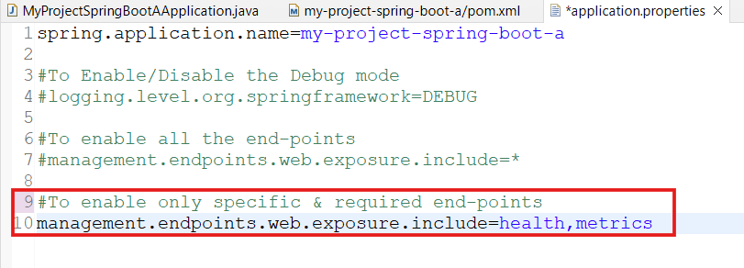

ST09: Exploring Spring Boot DevTools

- It increases developers productivity.

- This is not useful in the Productions as we do not make changes directly in production & we do not need to restart each time when we make any changes in the source files like the development region.

- That's why this is a very helpful feature for the developers as this allows autorestart of the servers when it detects any change.

- Important - This feature restarts the application only when a change is detected in the java files but not in the other files like - pom.xml. To get changes in the other file types, we need to manually restart the Server.

- However, we don’t want it to be part of the deployable unit. This can be achieved by adding scope as “runtime” in the Maven dependency while adding dependency for the DevTools.
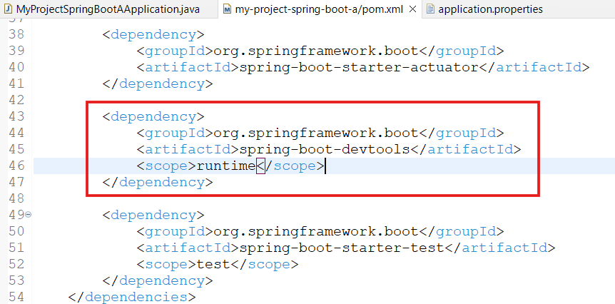

- Now, just once we need to restart the server & from next time onwards it will be auto-restarted to pick up the latest changes.

- For example:
Java Source code: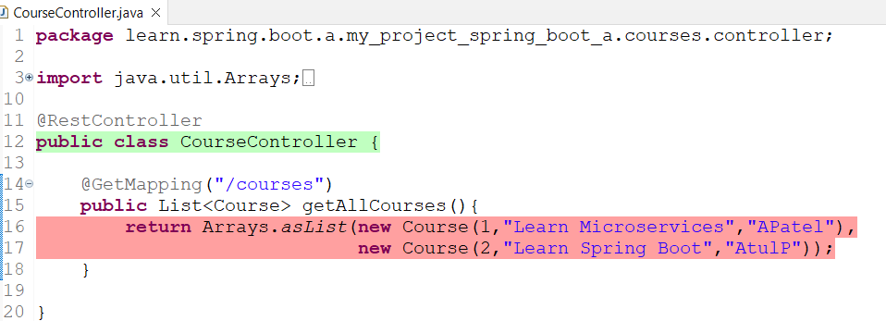
API Response:
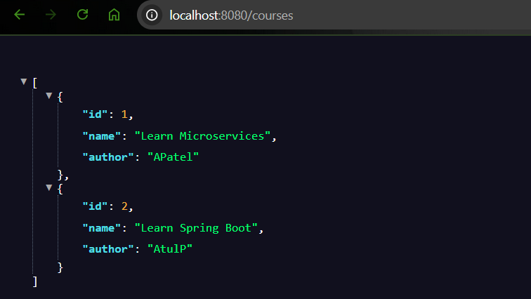

Now update the course details in the Java source code & save the code: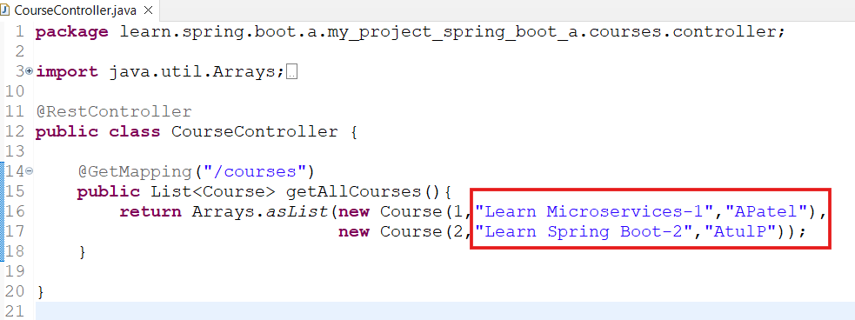

When we save the file, the server will auto-restart.

Refresh the URL to get the latest response
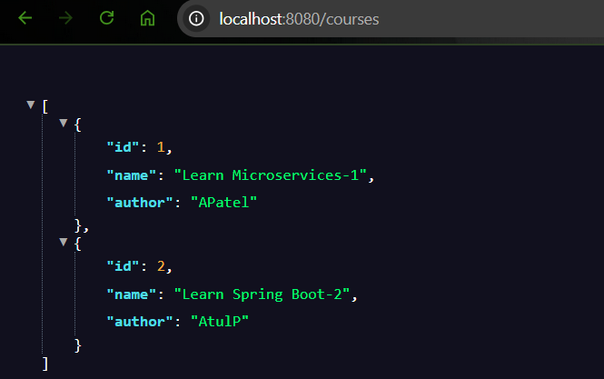

ST10: Comparison - Spring Boot vs Spring vs Spring mvc

When we talk about Spring Framework or Spring mvc or Spring or Spring Boot, we see that there are a lot of frameworks available & we get confused about where & which one to use.

Let’s get some understanding on the same.

- Spring Framework
  - The core features of Spring framework are Creating the Beans & Dependency Injection & Autowiring using Annotations like @Component, @Autowired, IOC Container, ApplicationContext, Component Scan etc ..

  - Spring also provides a number of Spring Modules & Spring Projects.

For example if we want to create a web application, it provides Spring mvc Module and if we don’t want to configure a lot of things & quickly build a project, it provides Spring Boot Project.

It provides a good Integration with Other Frameworks (Hibernate/JPA, JUnit & Mockito for Unit Testing)

- Spring MVC (Spring Module) - It builds web applications in a decoupled approach.
That means we need to do a lot of manual configurations for Dispatcher Servlet, ModelAndView and View Resolver etc.

Spring Boot Projects resolves all of these complications of manual configurations.

- Spring Boot (Spring Project):
It helps in building production ready applications quickly.

We do not need to manually configure Dispatcher Servlet, ModelAndView and View Resolver etc.

As soon as we add the starter-web(Spring web starter) dependency, everything gets auto-configured. So we do not need to worry about the framework configurations & we can directly focus on the Business Logics.

  - Starter Projects - Spring provides a variety of Starter projects that make it easy to build variety of applications
  - Auto configuration - It provides auto-configurations for the dependencies required & eliminates manual configuration to setup Spring, Spring MVC and other projects!
  - Enable production ready non functional features: It also provides production ready features:
    - Actuator : Enables Advanced Monitoring and Tracing of applications.
    - Embedded Servers - No need for separate application servers!
    - Default Error Handling

